Parent Success Skills:

Building a Community of Caring,

Support and Encouragement

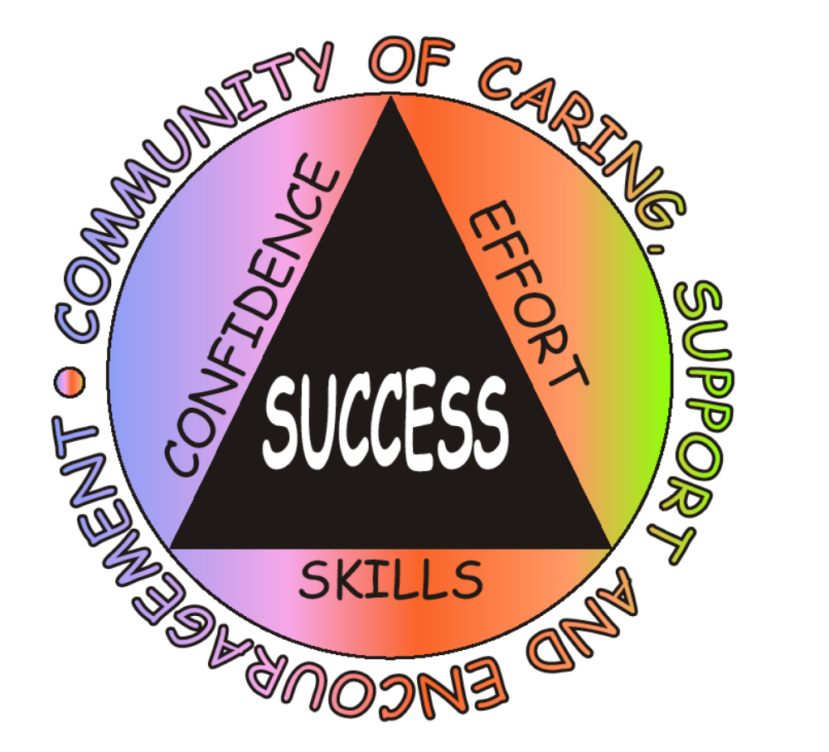

Presenter Manual

Greg Brigman, Ph.D.

Paul R. Peluso, Ph.D.

